Oxley Park Golf Club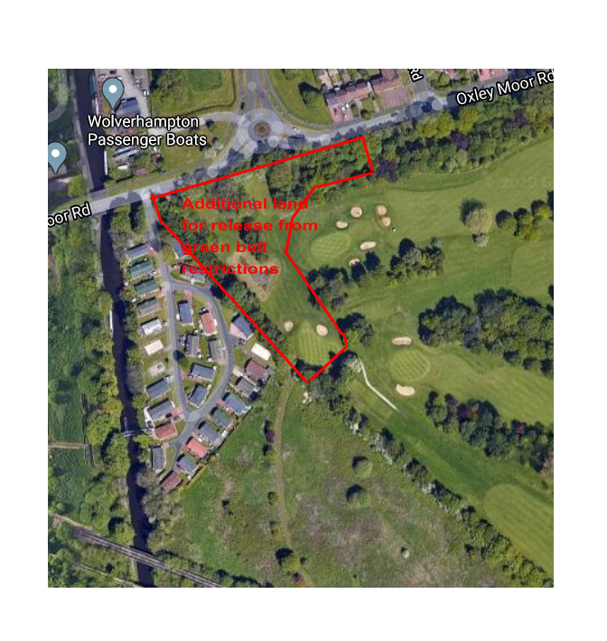

Potential additional land to be removed from green belt

If development on this site were to proceed, the one hole affected could be relocated by the Club onto other parts of its site