CORBETT MEADOW, STOURBRIDGE
PROPOSED LOCAL GREEN SPACE
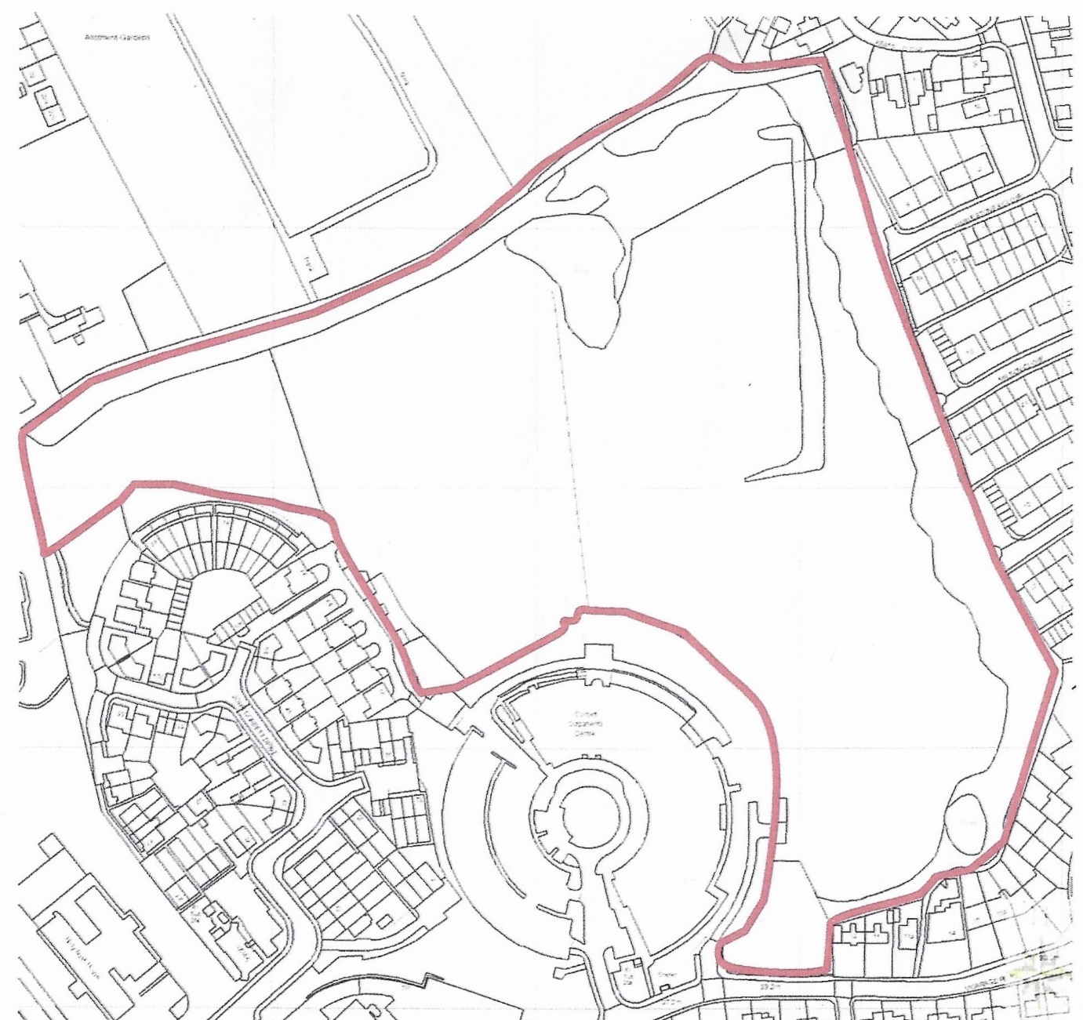

PRW / AUGUST 2020

